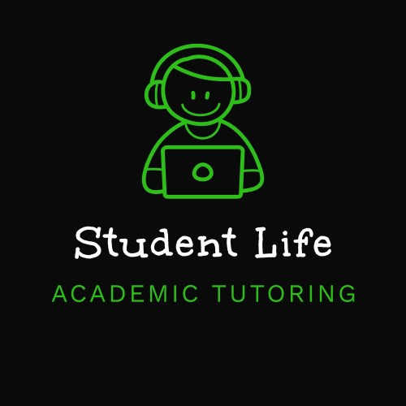
2025 Student - Onboarding.
Setup Instructions. Microsoft Teams & OneNote Installation guide.
Student Life Academic Tutoring Pty. Ltd.

Welcome to Student Life Academic Tutoring!
We like to keep things simple here.
Here you will find everything you need to know to begin getting support from Student Life. This guide will help you quickly set up and use Microsoft Teams & Microsoft OneNote.

What Do I Need to Do?
- ** Prepare for Session **
- ✅ Install Microsoft Teams and OneNote (Instructions below)
- ✅ Have all your assessment task/criteria sheets ready either paper copy or digital
- ✅ A writing/editing tool (Such as Microsoft Word)

- ** Set Up Your Space **
- ✅ Quiet Environment
- ✅ Stable Internet Connection
- 🎧 Headphones Recommended

- ** Join Your Session **
- ✅ Click the link emailed from your tutor at your scheduled session time
- ✅ Join as Guest or sign in with your Microsoft Account
- ✅ Ensure Microphone and Camera are enabled

- ** During Your Session **
- Assessment is broken down using the criteria/task sheet.
- Creating a plan to tackle the assessment using scaffolding and tutor guidance
- Tutor will use OneNote to help you organise all assessments
- Tutor will use OneNote to share all notes, resources, diagrams, plans during session

--Creating a Microsoft Account--
Creating a basic Microsoft Account will give you access to download the required software online for free. There is no cost associated with creating a free Microsoft account or downloading Microsoft Teams or OneNote.


Microsoft Teams
Teams is an online communication platform that allows tutors and students to meet face-to-face, share screens, and collaborate in real time during tutoring sessions.
How do I get Microsoft Teams?
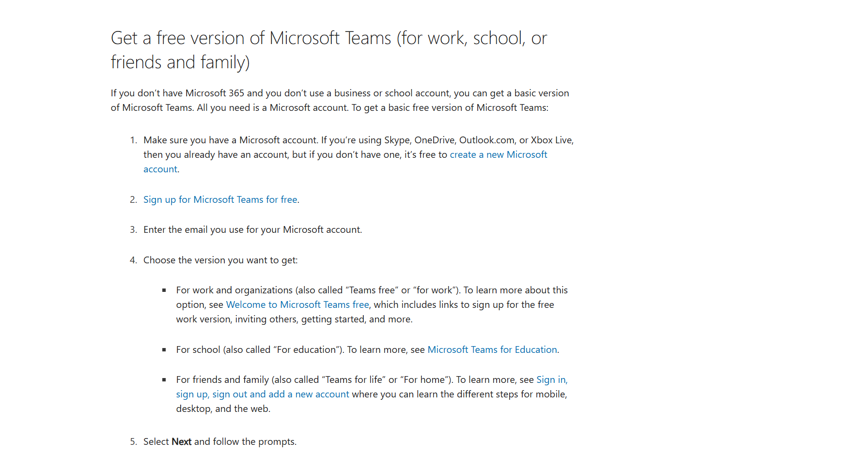
https://support.microsoft.com/en-gb/office/how-do-i-get-microsoft-teams-fc7f1634-abd3-4f26-a597-9df16e4ca65b
First things to know about meetings in Microsoft Teams:
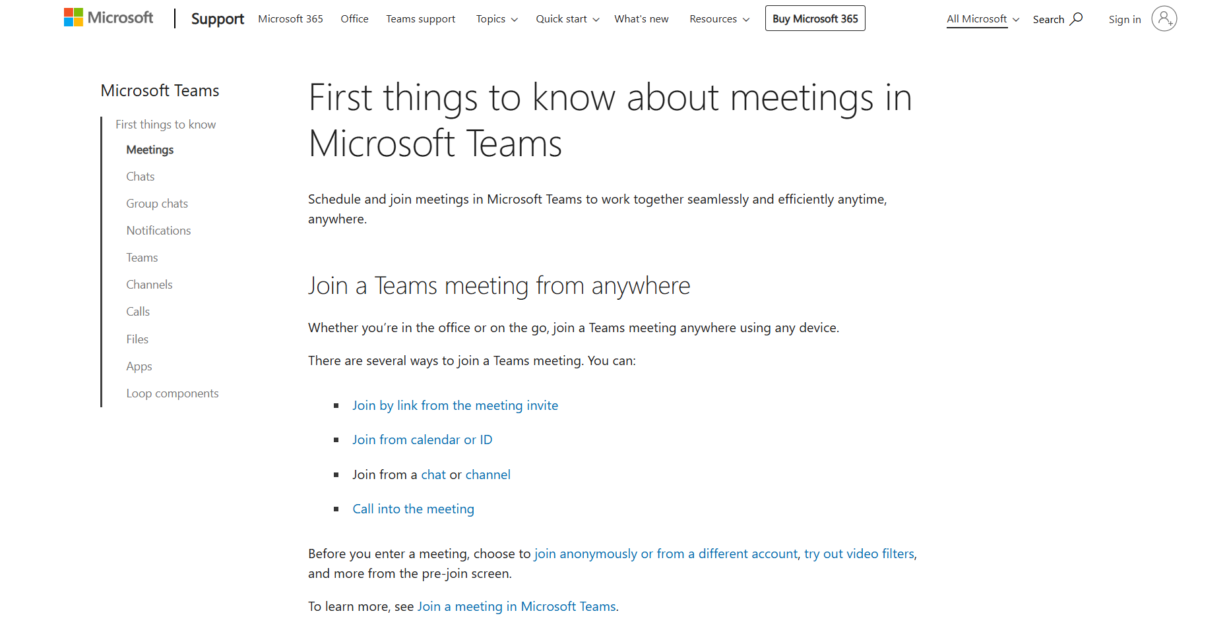
https://support.microsoft.com/en-us/office/first-things-to-know-about-meetings-in-microsoft-teams-526e6020-8985-4f81-84b3-04f9255751d5
Download link below:
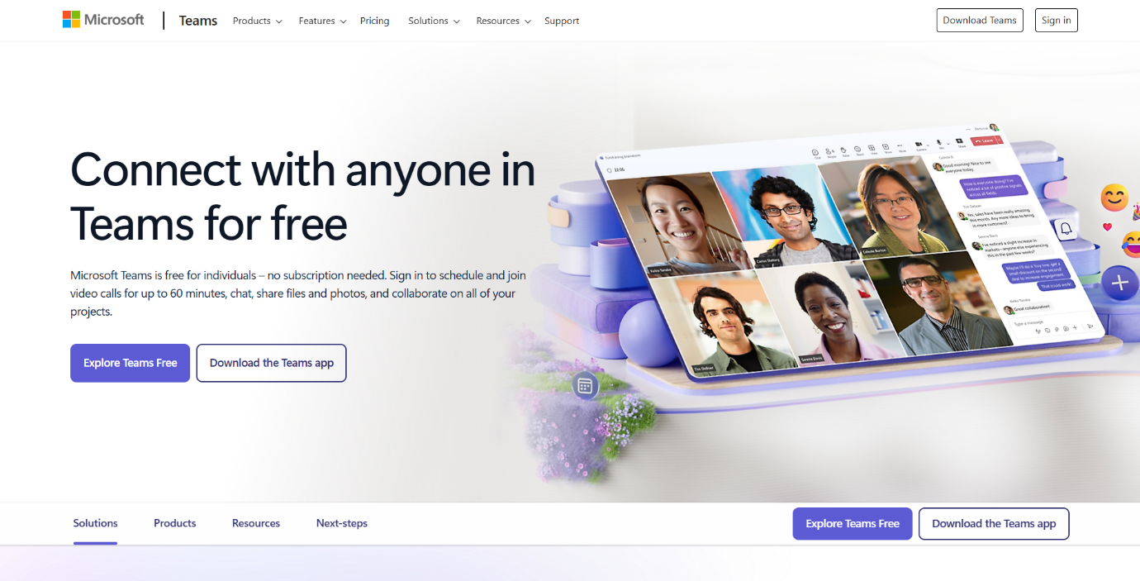
https://www.microsoft.com/en-au/microsoft-teams/teams-free

Joining your session:
https://support.microsoft.com/en-au/office/join-a-meeting-in-microsoft-teams-free-047b93e5-1777-4289-a3be-0ed6ca3fa12a#id0ebf=desktop
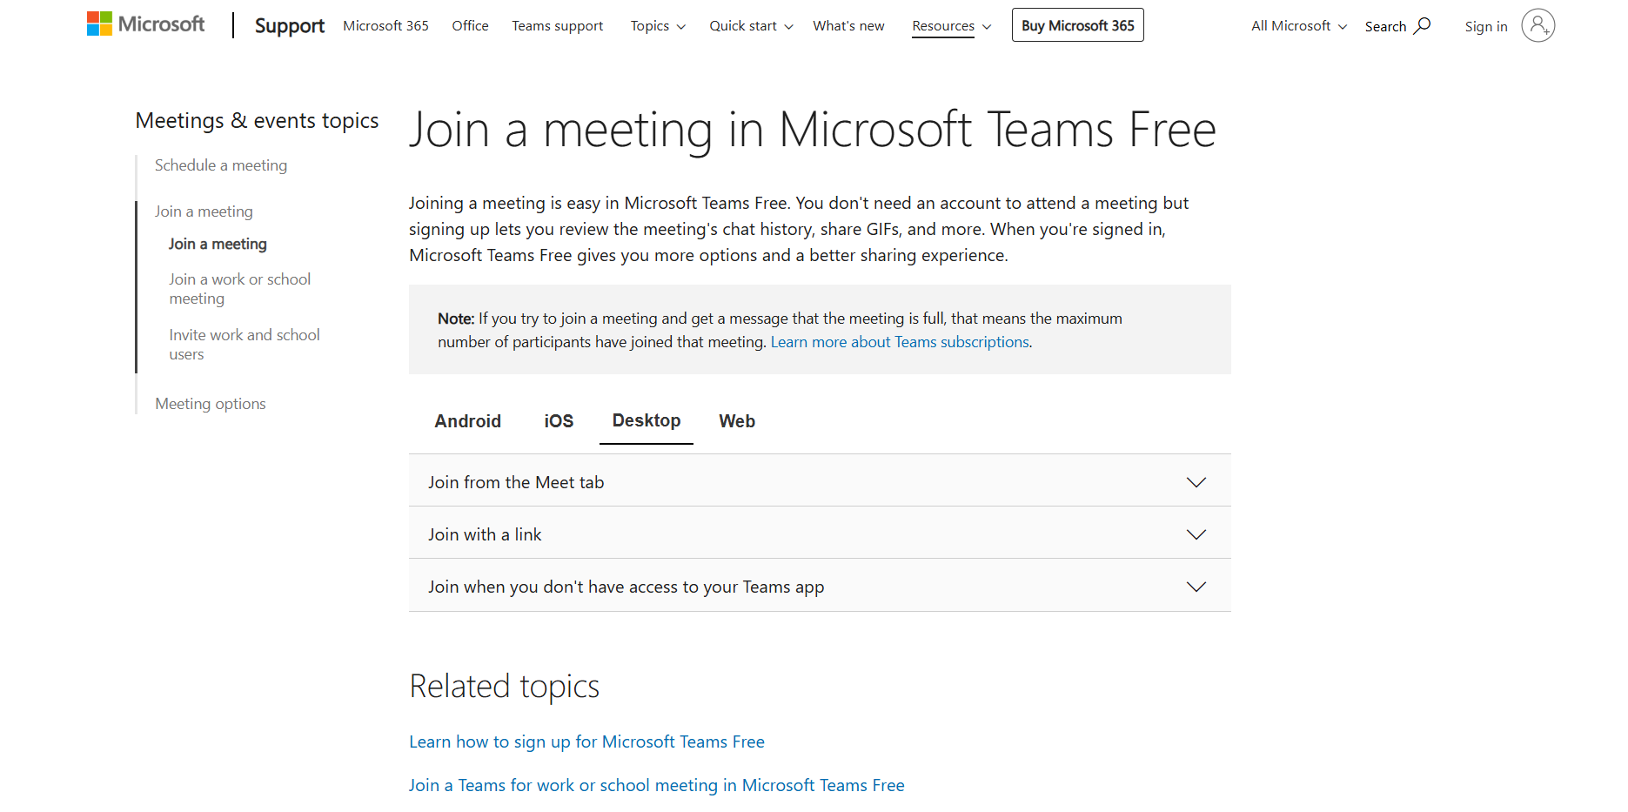


Microsoft OneNote
OneNote is a digital notebook that allows tutors and students to write, draw, and collaborate on schoolwork in real time.
How do I get Microsoft OneNote?
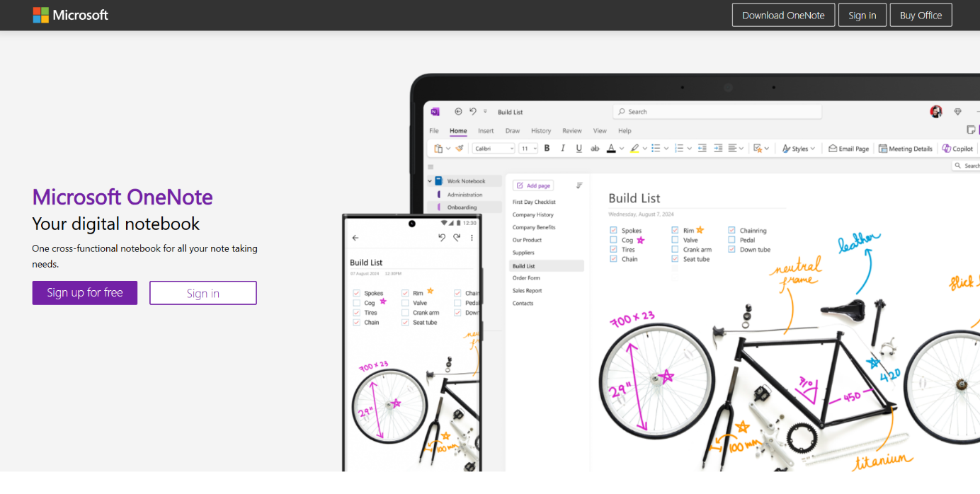
https://www.onenote.com/?public=1&wdorigin=ondcauth2&wdorigin=ondc

First things to know about using OneNote:
https://support.microsoft.com/en-au/office/start-using-onenote-6f4d0683-9b32-4467-9d38-76424d355673
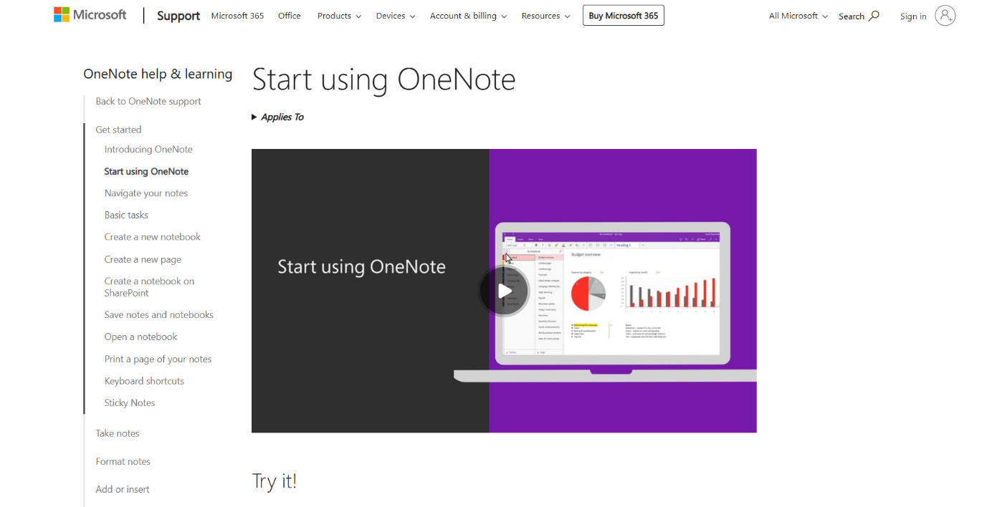

Download link below:
https://support.microsoft.com/en-gb/office/how-to-download-onenote-146efaac-d372-4412-abde-e00151ac202d
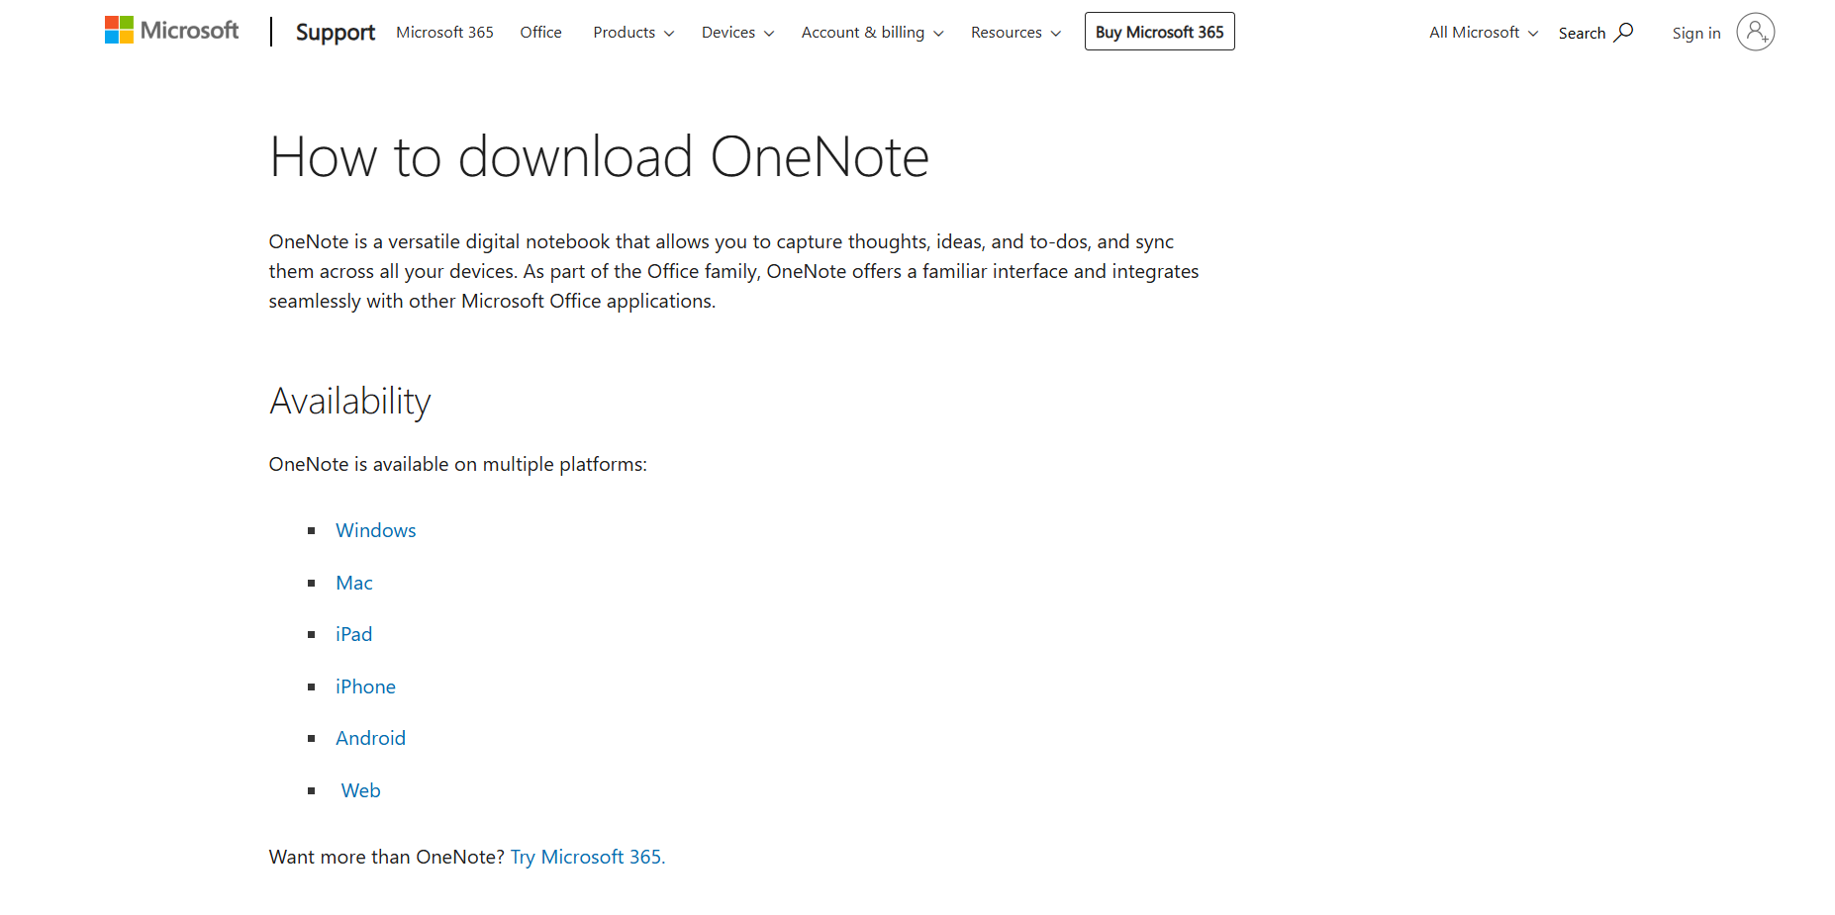

If you have any issues regarding the free installation of these products. Please consult this document below or email studentlifeacademictutoring@gmail.com.

